Case Study

Reconciling Cadburys and Olympic Sponsorship

WOMENS PARTICIPATION IN THE OLYMPIC GAMES
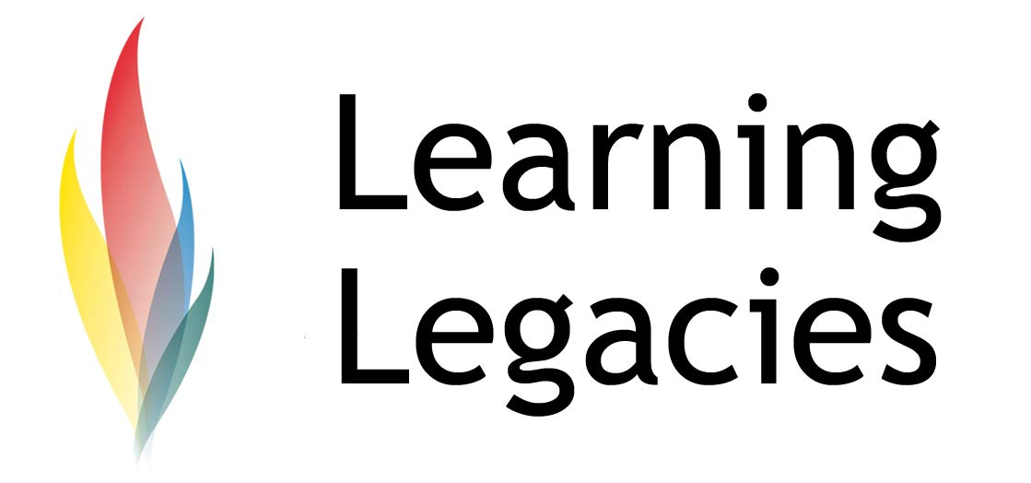
How can we reconcile a Cadbury’s sponsorship with 2012 Games legacies?

Cadbury has been named as the Official Treat Provider of the London 2012 Olympic and Paralympic Games. As a sponsor, Cadbury has a domestic two-tier sponsorship deal. The deal to become a two-tier supporter was agreed in 2008, with the establishment of Cadbury’s role as the Official Confectionery and Packaged Ice Cream Supporter of London 2012. The sponsorship arrangement allows Cadbury the right to use the London 2012 logo on their packaging, and provides them with marketing rights associated with Team GB. During the Games, Cadbury will have exclusive right to supply all confectionery and packaged ice cream sold within the Olympic Park and at other Olympic and Paralympic venues. This two-tier sponsorship package exists in tandem with a tier-three sponsorship of the Games via Cadbury’s Trident chewing gum brand.

The Cadbury official website states that ‘The London 2012 Games will be the biggest public event to happen in the UK during our lives and we believe Cadbury’s support for London 2012 will be great for Cadbury, the Games and for Britain.’ Cadbury has a long history (perhaps surprisingly) of involvement in sports sponsorship, having exhibited their involvement in the Sydney 2000 Olympic Games, Manchester Commonwealth Games in 2002 and the Melbourne Commonwealth Games in 2006.

In addition to their tier-two sponsorship, Cadbury’s has signed up to a 5-year sponsorship deal of the Weymouth and Portland National Sailing Academy (WPNSA), the Olympic Sailing Venue of London 2012. As part of the sponsorship package, Cadbury will enjoy a close relationship with both the elite stars and grass root level sailors who train and compete at the venue. The deal includes provision of Cadbury products to participants and spectators at the WPNSA throughout the duration of the sponsorship period. John Tweed, CEO of the Weymouth and Portland National Sailing Academy, commented that: “The Weymouth and Portland National Sailing Academy team are very inspired by Cadbury’s new involvement at this international sailing venue and we are looking forward to incorporating a fun sporting spirit into future events and legacy programme activities.”

Cadbury recently launched their ‘Spots v Stripes’ campaign to coincide with the build up to the London 2012 Games, and state that the focus of the campaign is to inspire millions of people from all walks of life to rediscover the spirit of playing games. Overall, Cadbury is using its Olympic 2012 sponsorship as a springboard from which it is launching its biggest ever marketing campaign – worth £50 million.

Financial Benefits

The Cadbury two-tier sponsorship deal is worth upwards of £20 million (two-tier sponsorships generally cost between £20-£40 million), a vital investment for LOCOG. Theoretically, the greater the investment secured in the Games, the greater the potential that LOCOG has to deliver on its
legacy objectives, including the development of a healthier nation. Furthermore, the company look set to enhance community involvement in sport via their 5 year sponsorship of the Olympic sailing centre.

There are concerns, however, that the cost of treating the childhood obesity epidemic in Britain might far financially outweigh this type of financial contribution.

Criticisms of the Sponsorship

Both Cadbury and LOCOG have been criticised for entering into a sponsorship agreement due to the high sugar and fat content of Cadbury’s products. Given that a legacy goal of the Games is to inspire healthy lifestyles, detractors argue that this choice of sponsor is unwise. For example, Christine Haigh, co-ordinator of the Children's Food Campaign, believes that whilst the 2012 Games provide an excellent opportunity to inspire young people across the UK to adopt healthier lifestyles, she remains sceptical that Cadbury’s sponsorship will assist in such a goal.

Childhood Obesity

Obesity is the term given to the state of being seriously overweight to a degree that negatively affects the health of the individual. Effects of obesity include musculoskeletal problems (for example, bow legs), intracranial hypertension (causing headaches & blurred vision), hypoventilation (causing daytime drowsiness,

Case Study

Reconciling Cadburys and Olympic Sponsorship

WOMENS PARTICIPATION IN THE OLYMPIC GAMES
snoring and heart failure), gall bladder disease, polycystic ovary syndrome, high blood pressure
and high levels of blood fats. It also increases the risk of insulin resistance and Type II Diabetes. The psychological effects of obesity are also well-documented and include low self-esteem and low self-confidence. The causes of obesity are straightforward; the ingestion of too much sugar and fat, and a lack of exercise that prohibits the burning of excess calories.

Obesity in children is linked to a number of health complications and is positively correlated to obesity in adulthood. Worryingly, there has been a shift in incidences of obesity-related Type II Diabetes, with an increasing number of children contracting the disease. Overall, around 27% of children in the UK are now overweight, with some reports indicating a 15-fold increase in the prescription of anti-obesity drugs to children in the last 10 years. The incidence of overweight children is often linked to the presence of overweight parents in the household.

According to a UCL Institute of Child Health and University of London study, published in the British Journal of Clinical Pharmacology, Orlistat, Sibutramine and Rimonbant are routinely prescribed as anti-obesity treatments for adults and children. In 2005, the cost to the NHS of supplying two drugs, orlistat and sibutramine in England was £38.2 million. It is anticipated that the costs to the NHS of treating obesity will be over £6billion in 4 years, and could rise to as much as £45 billion a year by 2050, if one factors in the associated costs of increased levels of obesity-related diabetes, strokes and heart disease, in addition to the loss of earnings that would be experienced by those too obese to work.

Cadbury’s Response to Criticisms

Cadbury argue against criticisms, saying that they are the Official Treat Provider – and that their products are exactly that – a treat (something that is to be enjoyed only on rare, special occasions). Their official website states that ‘Our products are treats, which bring a moment of fun and pleasure and a smile to the face. We want to bring that same fun, pleasure and smile to the 2012 Games.’ Clearly, the focus of Cadbury is to communicate the message that their products are to be enjoyed for a ‘moment’ as opposed to featuring regularly and consistently in our diets.

Cadbury make a clear point that they will not market their products to young children, citing a long-term strategy that omits any television advertising of their products during children’s programming. Cadbury’s further defended their sponsorship approach by stating that they would never utilise London 2012 branding in conjunction with the sales of multiple purchases (such as promotions involving the collection of tokens).

This decision may well have been a response to the negative reactions experienced by Cadbury as a result of its ill-fated ‘Get Active!’ campaign. That campaign had associated themselves with sport and exercise by encouraging children to collect and then redeem vouchers for school sports equipment – with vouchers attained through the purchase of chocolate bars. The irony of encouraging children to eat multiple bars of chocolate in order to collect school sports tokens

Case Study

Reconciling Cadburys and Olympic Sponsorship

WOMENS PARTICIPATION IN THE OLYMPIC GAMES
was not lost on the general public or the Government and the campaign came under heavy fire. At the time, the public health minister Melanie Johnson stated that she hoped that we would never see similar initiatives of that kind again.

The company also cites its clear nutritional labelling on the front of each product that informs the consumer clearly of the amount of fat and sugar that can be found in each product (part of the ‘Be Treatwise’ initiative) – alongside its membership of the Business 4 Life initiative which works with the British Government’s ‘Change for Life’ campaign.

Whilst detractors suggest that Cadbury and other confectionery providers play a role in the increasing levels of childhood obesity, one might also argue that consumers should exercise personal control in limiting their enjoyment of Cadbury’s products to the occasional treat, and in so doing, maintain a healthy and balanced diet that would not lead to obesity or any associated health concerns.

Further Information
- Childhood Obesity: NHS Choices
http://www.nhs.uk/change4life/Documents/pdf/Help_stop_childhood_obesity.pdf
- Cadbury’s Sports v Stripes Campaign
http://www.spotsvstripes.com/win

Discussion
- Do you feel that Cadbury’s is an appropriate sponsor for the London 2012 Games?
- Do you feel that the choice to label Cadbury’s as the ‘Official Treat Provider’ of the Games may have been taken as a means of countering controversy?
- If you were a member of the coalition, responsible for lowering childhood obesity, what strategies would you devise to tackle the problem?
- What will the financial legacy of Cadbury’s sponsorship be?

Case Study

Reconciling Cadburys and Olympic Sponsorship

WOMENS PARTICIPATION IN THE OLYMPIC GAMES

Case Study

Reconciling Cadburys and Olympic Sponsorship

WOMENS PARTICIPATION IN THE OLYMPIC GAMES
This resource was produced as part of the 2012 Learning Legacies Project managed by the HEA Hospitality, Leisure, Sport and Tourism Subject Centre at Oxford Brookes University and was released as an Open Educational Resource. The project was funded by HEFCE and part of the JISC/HE Academy UKOER programme. Except where otherwise noted above and below, this work is released under a Creative Commons Attribution only licence.

Exceptions to the Licence
The name of Oxford Brookes University and the Oxford Brookes University logo are the name and registered marks of Oxford Brookes University. To the fullest extent permitted by law Oxford Brookes University reserves all its rights in its name and marks, which may not be used except with its written permission. The JISC logo is licensed under the terms of the Creative Commons Attribution-Non-Commercial-No Derivative Works 2.0 UK: England & Wales Licence. All reproductions must comply with the terms of that licence.

The Higher Education Academy logo is owned by the Higher Education Academy Limited and may be freely distributed and copied for educational purposes only, provided that appropriate acknowledgement is given to the Higher Education Academy as the copyright holder and original publisher.

Reusing this work
To refer to or reuse parts of this work please include the copyright notice above including the serial number. The only exception is if you intend to only reuse a part of the work with its own specific copyright notice, in which case cite that.

If you create a new piece of work based on the original (at least in part), it will help other users to find your work if you modify and reuse this serial number. When you reuse this work, edit the serial number by choosing 3 letters to start (your initials or institutional code are good examples), change the date section (between the colons) to your creation date in ddmmyy format and retain the last 5 digits from the original serial number. Make the new serial number your copyright declaration or add it to an existing one, e.g. ‘abc:101011:011cs’.

If you create a new piece of work or do not wish to link a new work with any existing materials contained within, a new code should be created. Choose your own 3-letter code, add the creation date and search as below on Google with a plus sign at the start, e.g. ‘+tom:030504’. If nothing comes back citing this code then add a new 5-letter code of your choice to the end, e.g.; ‘:01lex’, and do a final search for the whole code. If the search returns a positive result, make up a new 5-letter code and try again. Add the new code your copyright declaration or add it to an existing one.

Marketing Week, Thursday 3rd Nov, 2011: http://www.marketingweek.co.uk/news/cadbury-to-sponsor-2012-olympics-sailing-venue/3009409.article

